Bounce Architecture Document

Program Name: | Inventory And DSD | Program Manager: | Lynn Guyot
Project Name: | Inventory Allocation | Project Manager: | Israel.Rajkumar
Project Number: |  | Account Unit:
Sponsor: |  | Business Owner:

Document Version Control
Date | Version # | Describe Revision(s) | Author(s)
03/16/2012 | 1.0 | Initial version | Cognizant

Overview:

Purpose
The purpose of this Document is to explain about Bounce Architecture and the new application development technical flow of DM Summary page.

Bounce Architecture –
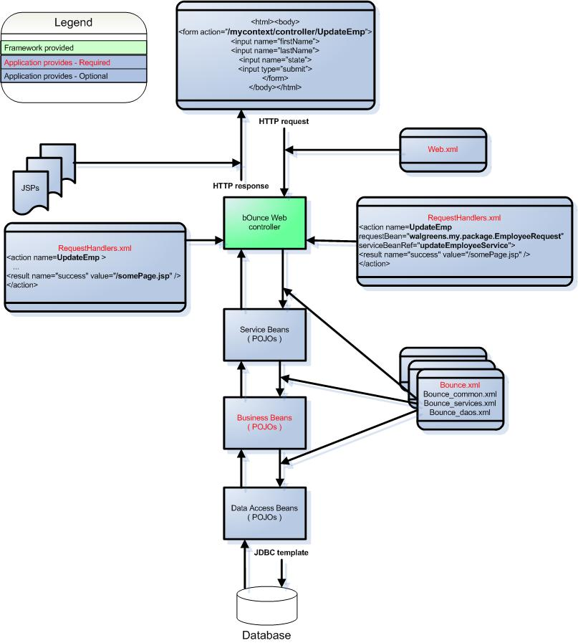

How an HTTP request is processed:

- The Web browser sends a request to the bounce Web controller servlet. This request contains an "action" string as extra path information.
- The controller servlet looks for an action tag that matches the action string in the "RequestHandlers.xml" file.
- All request parameters and form values are loaded into the request bean.
- If a preprocessor bean is provided, the preProcess() method is called.
- If configured in RequestHander.xml, The request bean is then validated using Apache Commmons Validation.
- If a validator bean is provided, The validate() method is called.
- The service bean 'execute' method is called.
- If a post processor bean has been provided, the postProcess() method is called.
- The response bean contains a "resultString" field, and the value in that determines how the response bean is presented to the user. There are currently four possibilities:
  - Forward to a JSP.
  - Redirect to a URL.
  - Forward to a JSP using Tiles to apply a template JSP to it.
  - Use a custom View Helper class to present the response to the user in a special format, like an Excel spreadsheet, as JSON data, as a PDF, etc

DM’s Summary Page Functionality Code Flow–

When DM Clicks on Summary link in Main Page, the Request flows from JSP to Service Layer, Intern the request is passed to BO Layer and finally to DAO Layer. In DAO Layer the data’s are fetched from DB and the response is passed back to the Summary JSP in wise versa.

JSP
Service Layer
BO Layer
DAO Layer
Database

DM’s Summary JSP Page –

